B
Adjacency matrix
(1) n = 7
 | A | B | C | D | E | F | G
A | 0 | 1 | 1 | 1 | 0 | 0  C  A  E  G | 1
B | 1 | 0 | 1 | 0 | 1 | 0 | 0
C | 1 | 1 | 0 | 0 | 1 | 0 | 0
D | 1 | 0 | 0 | 0 | 0 | 1 | 0
E | 0 | 1 | 1 | 0 | 0 | 1 | 1
F | 0 | 0 | 0 | 1 | 1 | 0  D  F | 0
G | 1 | 0 | 0 | 0 | 1 | 0 | 0

Breadth-first traverse: A B C D G E F
Depth-first traverse: A B C E F D G

=======================================================================
(2) n = 9

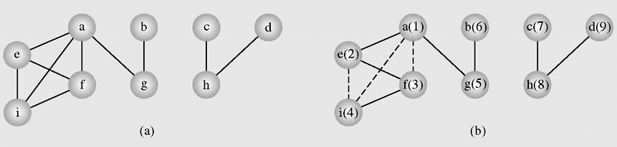

Breadth-first traverse: A E F G I B C H D
Depth-first traverse: A E F I G B C H D

9
0 0 0 0 1 1 1 0 1
0 0 0 0 0 0 1 0 1
0 0 0 0 0 0 0 1 0
0 0 0 0 0 0 0 1 0
1 0 0 0 0 1 0 0 1
1 0 0 0 1 0 0 0 1
1 1 0 0 0 0 0 0 0
0 0 1 1 0 0 0 0 0
1 0 0 0 1 1 0 0 0

=======================================================================
(3) n = 10

A

B
D
E
H
C
F
G
J

I

Breadth-first traverse: A B C E G D H F I J
Depth-first traverse: A B C G E D H F I J

 | A | B | C | D | E | F | G | H | I | J
A | 0 | 1 | 1 | 0 | 0 | 0 | 0 | 0 | 0 | 0
B | 1 | 0 | 1 | 0 | 1 | 0 | 0 | 0 | 0 | 0
C | 1 | 1 | 0 | 0 | 0 | 0 | 1 | 0 | 0 | 0
D | 0 | 0 | 0 | 0 | 0 | 0 | 0 | 1 | 0 | 0
E | 0 | 1 | 0 | 0 | 0 | 0 | 0 | 0 | 0 | 0
F | 0 | 0 | 0 | 0 | 0 | 0 | 0 | 0 | 1 | 0
G | 0 | 0 | 1 | 0 | 0 | 0 | 0 | 0 | 0 | 0
H | 0 | 0 | 0 | 1 | 0 | 0 | 0 | 0 | 0 | 0
I | 0 | 0 | 0 | 0 | 0 | 1 | 0 | 0 | 0 | 0
J | 0 | 0 | 0 | 0 | 0 | 0 | 0 | 0 | 0 | 0

=======================================================================
(4) n = 10

Weighted adjacency matrix (in the program the value 99 means the infinity (∞):

 | A | B | C | D | E | F | G
A | 0 | 10 | ∞ | ∞ | ∞ | ∞ | 8
B | ∞ | 0 | 2 | 10 | 25 | 80 | ∞
C | 30 | ∞ | 0 | 8 | 3 | 20 | ∞
D | 20 | ∞ | ∞ | 0 | ∞ | 5 | 10
E | ∞ | ∞ | ∞ | 4 | 0 | ∞ | ∞
F | 8 | ∞ | ∞ | ∞ | ∞ | 0 | 5
G | 8 | ∞ | ∞ | ∞ | ∞ | ∞ | 0

Problem: Find shortest path from the vertex A to the vertex F.

10
30
2
25
10
80
8
4
E
5
20
3
20
10
8
5
8
B
A
C
D
F
G

=======================================================================
(5) n = 5

5
A
C
B
D
E
0 1 0 0 1
1 0 1 1 1
0 1 0 1 0
0 1 1 0 2
1 1 0 2 0

